## **LAB 1**

## OBJECTIVE: WAP in C to create singly linked list and demonstrate insert, delete and traverse operation.

**THEORY:**

C++ A singly linked list is a linear data structure that stores data in nodes that are linked together in a chain. Each node has a value and a pointer to the next node in the list

. 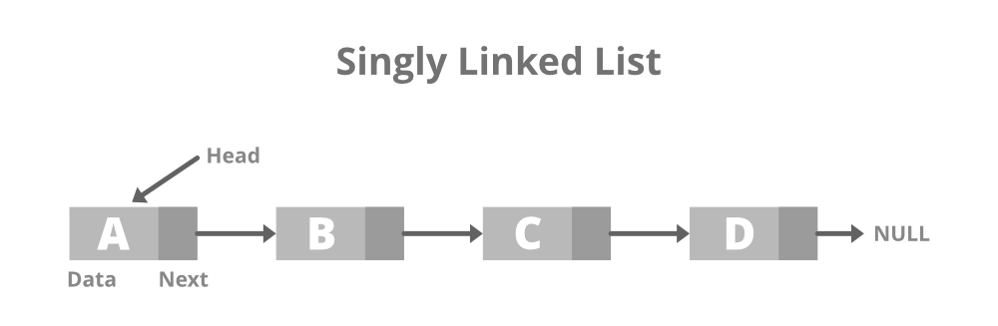

Operations to perform in single linked list are mention bellow:

1. Insert Operation
   1. Insert at beginning
   2. Insert at Position
   3. Insert at End
2. Delete Operation
   1. Delete at beginning
   2. Delete at position
   3. Delere at End
3. Traverse Operation
   1. Display items

## PROGRAMS

*#include<stdio.h>*

*#include<stdlib.h>*

*#include<conio.h>*

*// Single Linked List structure...*

*struct Node {*

*int data;*

*struct Node *next;*

*}; typedef struct Node node;*

*node *head = NULL;*

*// Function to create new node...*

*node* createNewNode(int item) {*

*node *newnode = (node*)malloc(sizeof(node));*

*newnode->data = item;*

*newnode->next = NULL;*

*return newnode;*

*}*

*// Function to insert at beginning*

*void insertAtBeg(int item) {*

*node *newnode = createNewNode(item);*

*newnode->next = head;*

*head = newnode;*

*}*

*// Function to insert at a position*

*void insertAtPos(int pos, int item) {*

*if (pos < 1) {*

*printf("\n\t\t!!! Invalid Position...\n");*

*return;*

*}*

*if (pos == 1) {*

*insertAtBeg(item);*

*return;*

*}*

*node *temp = head;*

*node *newnode = createNewNode(item);*

*for (int i = 1; i < pos - 1 && temp != NULL; i++)*

*temp = temp->next;*

*if (temp != NULL) {*

*newnode->next = temp->next;*

*temp->next = newnode;*

*} else {*

*printf("\n\t\t!!! Invalid Position...\n");*

*}*

*}*

*// Function to insert at the end*

*void insertAtEnd(int item) {*

*node *newnode = createNewNode(item);*

*if (head == NULL) head = newnode;*

*node *temp = head;*

*while (temp->next != NULL)*

*temp = temp->next;*

*temp->next = newnode;*

*}*

*// Function to delete at the beginning*

*void deleteAtBeg(){*

*if(head==NULL) printf("\n\t!!!Empty Node list...\n");*

*else head = head->next;*

*}*

*// Function to delete at position*

*void deleteAtPos(int pos){*

*if (pos < 1) {*

*printf("\n\t\t!!! Invalid Position...\n");*

*return;*

*}*

*if (pos == 1) {*

*deleteAtBeg();*

*return;*

*}*

*node *temp = head;*

*for (int i = 1; i < pos - 1 && temp != NULL; i++)*

*temp = temp->next;*

*if (temp != NULL)*

*temp->next = (temp->next)->next;*

*else {*

*printf("\n\t\t!!! Invalid Position...\n");*

*}*

*}*

*// Function to delete at end*

*void deleteAtEnd(){*

*if(head==NULL) printf("\n\t!!!Empty Node list...\n");*

*else{*

*node *temp = head;*

*while((temp->next)->next!=NULL)*

*temp = temp->next;*

*temp->next = NULL;*

*}*

*}*

*// Function to display the linked list*

*void display() {*

*node *temp = head;*

*printf("\n\tList of data:\n\t");*

*if (head == NULL) {*

*printf("\t!!! Empty Node list...\n");*

*return;*

*}*

*while (temp != NULL) {*

*printf("%d -> ", temp->data);*

*temp = temp->next;*

*}*

*printf("NULL\n");*

*}*

*// Menu-driven Dashboard*

*void Dashboard() {*

*int choice, value, pos;*

*do {*

*system("cls");*

*display();*

*printf("\n\tEnter operation: \n");*

*printf("\t\t1. Insert at Beginning\n");*

*printf("\t\t2. Insert at Position\n");*

*printf("\t\t3. Insert at End\n");*

*printf("\t\t4. Delete at Beginning\n");*

*printf("\t\t5. Delete at Position\n");*

*printf("\t\t6. Delete at End\n");*

*printf("\t\t7. Exit\n\n");*

*printf("\tEnter your choice: ");*

*scanf("%d", &choice);*

*switch (choice) {*

*case 1:*

*printf("\n\tEnter value to insert: ");*

*scanf("%d", &value);*

*insertAtBeg(value);*

*break;*

*case 2:*

*printf("\n\tEnter position: ");*

*scanf("%d", &pos);*

*printf("\tEnter value to insert: ");*

*scanf("%d", &value);*

*insertAtPos(pos, value);*

*break;*

*case 3:*

*printf("\n\tEnter value to insert: ");*

*scanf("%d", &value);*

*insertAtEnd(value);*

*break;*

*case 4:*

*deleteAtBeg();*

*break;*

*case 5:*

*printf("\n\tEnter position: ");*

*scanf("%d", &pos);*

*deleteAtPos(pos);*

*break;*

*case 6:*

*deleteAtEnd();*

*break;*

*case 7:*

*printf("\n\tExiting program...\n");*

*break;*

*default:*

*printf("\n\tInvalid choice! Please try again.\n");*

*}*

*printf("\n\tPress Enter to continue...");*

*getch();*

*} while (choice != 7);*

*}*

*int main() {*

*Dashboard();*

*return 0;*

*}*

Output:

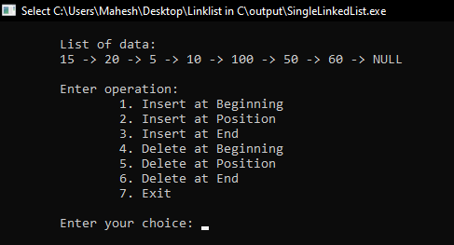 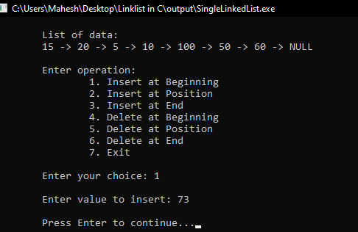

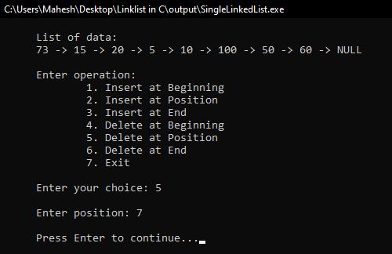 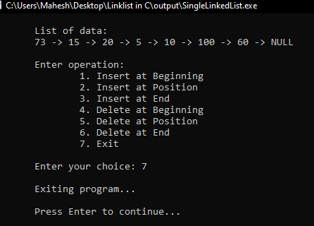

RESULTS AND DISCUSSION:

The stuents are successful to write code for single linked list in C programming. This program helps to understand basics of Data structure. The program have menu driven functioality to perform operations in single linked list.

CONCLUSION:

This laboratory exercise provided a hands-on experience in DAS. Students gained practical knowledge of implementing basic in single linked list and now better equipped to undertake more complex programming tasks in the future.

## **LAB 2**

## OBJECTIVE: WAP in C to create doubly linked list and demonstrate insert, delete and traverse operation.

## THEORY:

A doubly linked list is a data structure that consists of nodes that are linked together in both directions. Each node has three parts: data, a pointer to the next node, and a pointer to the previous node.

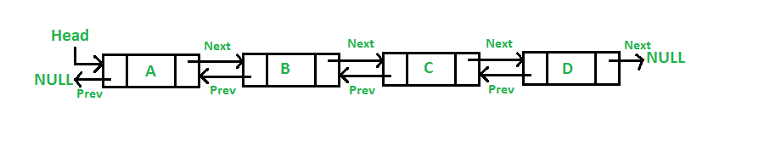

Operations to perform in single linked list are mention bellow:

1. Insert Operation
   1. Insert at beginning
   2. Insert at Position
   3. Insert at End
2. Delete Operation
   1. Delete at beginning
   2. Delete at position
   3. Delere at End
3. Traverse Operation
   1. Display items

## PROGRAM:

*#include<stdio.h>*

*#include<stdlib.h>*

*#include<conio.h>*

*// Doubly Linked List structure...*

*struct Node {*

*int data;*

*struct Node *prev;*

*struct Node *next;*

*}; typedef struct Node node;*

*node *head = NULL;*

*// Function to create new node...*

*node* createNewNode(int item) {*

*node *newnode = (node*)malloc(sizeof(node));*

*newnode->data = item;*

*newnode->prev = NULL;*

*newnode->next = NULL;*

*return newnode;*

*}*

*// Function to insert at beginning*

*void insertAtBeg(int item) {*

*node *newnode = createNewNode(item);*

*if (head != NULL) {*

*newnode->next = head;*

*head->prev = newnode;*

*}*

*head = newnode;*

*}*

*// Function to insert at a specific position*

*void insertAtPos(int pos, int item) {*

*if (pos < 1) {*

*printf("\n\t\t!!! Invalid Position...\n");*

*return;*

*}*

*if (pos == 1) {*

*insertAtBeg(item);*

*return;*

*}*

*node *temp = head;*

*node *newnode = createNewNode(item);*

*for (int i = 1; i < pos - 1 && temp != NULL; i++)*

*temp = temp->next;*

*if (temp != NULL) {*

*newnode->next = temp->next;*

*if (temp->next != NULL)*

*temp->next->prev = newnode;*

*temp->next = newnode;*

*newnode->prev = temp;*

*} else {*

*printf("\n\t\t!!! Invalid Position...\n");*

*}*

*}*

*// Function to insert at the end*

*void insertAtEnd(int item) {*

*node *newnode = createNewNode(item);*

*if (head == NULL) {*

*head = newnode;*

*return;*

*}*

*node *temp = head;*

*while (temp->next != NULL)*

*temp = temp->next;*

*temp->next = newnode;*

*newnode->prev = temp;*

*}*

*// Function to delete at the beginning*

*void deleteAtBeg(){*

*if(head == NULL) printf("\n\t!!!Empty Node list...\n");*

*else {*

*head = head->next;*

*if (head != NULL)*

*head->prev = NULL;*

*}*

*}*

*// Function to delete at position*

*void deleteAtPos(int pos){*

*if (pos < 1) {*

*printf("\n\t\t!!! Invalid Position...\n");*

*return;*

*}*

*if (pos == 1) {*

*deleteAtBeg();*

*return;*

*}*

*node *temp = head;*

*for (int i = 1; i < pos && temp != NULL; i++)*

*temp = temp->next;*

*if (temp != NULL) {*

*if (temp->prev != NULL)*

*temp->prev->next = temp->next;*

*if (temp->next != NULL)*

*temp->next->prev = temp->prev;*

*} else {*

*printf("\n\t\t!!! Invalid Position...\n");*

*}*

*}*

*// Function to delete at end*

*void deleteAtEnd(){*

*if(head == NULL) printf("\n\t!!!Empty Node list...\n");*

*else {*

*node *temp = head;*

*while (temp->next != NULL)*

*temp = temp->next;*

*if (temp->prev != NULL)*

*temp->prev->next = NULL;*

*else*

*head = NULL;*

*}*

*}*

*// Function to display the linked list*

*void display() {*

*node *temp = head;*

*printf("\n\tList of data:\n\t");*

*if (head == NULL) {*

*printf("\t!!! Empty Node list...\n");*

*return;*

*}*

*while (temp != NULL) {*

*printf("%d <-> ", temp->data);*

*temp = temp->next;*

*}*

*printf("NULL\n");*

*}*

*// Menu-driven Dashboard*

*void Dashboard() {*

*int choice, value, pos;*

*do {*

*system("cls");*

*display();*

*printf("\n\tEnter operation: \n");*

*printf("\t\t1. Insert at Beginning\n");*

*printf("\t\t2. Insert at Position\n");*

*printf("\t\t3. Insert at End\n");*

*printf("\t\t4. Delete at Beginning\n");*

*printf("\t\t5. Delete at Position\n");*

*printf("\t\t6. Delete at End\n");*

*printf("\t\t7. Exit\n\n");*

*printf("\tEnter your choice: ");*

*scanf("%d", &choice);*

*switch (choice) {*

*case 1:*

*printf("\n\tEnter value to insert: ");*

*scanf("%d", &value);*

*insertAtBeg(value);*

*break;*

*case 2:*

*printf("\n\tEnter position: ");*

*scanf("%d", &pos);*

*printf("\tEnter value to insert: ");*

*scanf("%d", &value);*

*insertAtPos(pos, value);*

*break;*

*case 3:*

*printf("\n\tEnter value to insert: ");*

*scanf("%d", &value);*

*insertAtEnd(value);*

*break;*

*case 4:*

*deleteAtBeg();*

*break;*

*case 5:*

*printf("\n\tEnter position: ");*

*scanf("%d", &pos);*

*deleteAtPos(pos);*

*break;*

*case 6:*

*deleteAtEnd();*

*break;*

*case 7:*

*printf("\n\tExiting program...\n");*

*break;*

*default:*

*printf("\n\tInvalid choice! Please try again.\n");*

*}*

*printf("\n\tPress Enter to continue...");*

*getch();*

*} while (choice != 7);*

*}*

*int main() {*

*Dashboard();*

*return 0;*

*}*

Output:

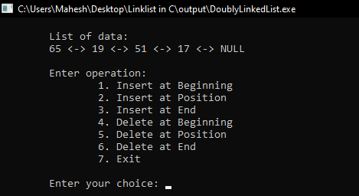 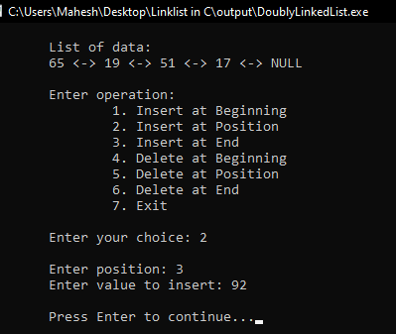

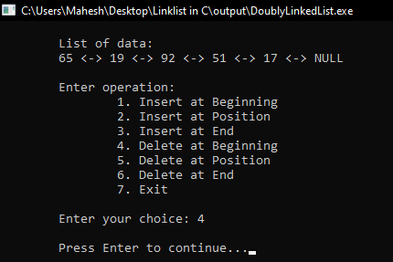 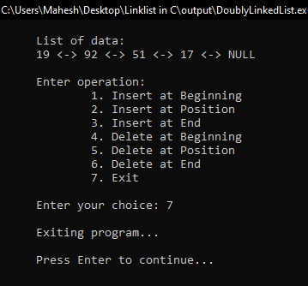

RESULTS AND DISCUSSION:

The stuents are successful to write code for doubly linked list in C programming. This program helps to understand basics of Data structure. The program have menu driven functioality to perform operations in doubly linked list.

CONCLUSION:

This laboratory exercise provided a hands-on experience in DAS. Students gained practical knowledge of implementing basic in doubly linked list and now better equipped to undertake more complex programming tasks in the future.

## **LAB 3**

## OBJECTIVE:

To illustrate the concept of different types of constructors (default, parameterized and copy) in C++.

## THEORY:

In C++, a constructor is a special member function of a class that is automatically called when an object of that class is created. It is used to initialize the object's data members and to allocate resources if necessary. Types of constructor are mentioned below.

1. Default Constructor

A default constructor is one that takes no arguments. If no constructor is defined in a class, the compiler provides a default constructor.

1. Parameterized Constructor

A parameterized constructor takes arguments and is used to initialize objects with specific values.

1. Copy Constructor

A copy constructor initializes an object using another object of the same class. It takes a reference to an object of the same class as a parameter.

## PROGRAMS:

1. Write a class Person with a constructor that initializes the name and age of the person.

*#include <iostream>*

*using namespace std;*

*class Persion{*

*string name;*

*int age;*

*public:*

*Persion(string n,int a):name(n),age(a){}*

*void display(){*

*cout<<"Name: "<<name<<endl;*

*cout<<"Age: "<<age<<endl;*

*}*

*};*

*int main(){*

*Persion p("Ramesh",25);*

*p.display();*

*return 0;*

*}*

Output:

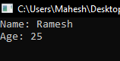

1. Write a program to demonstrate the use of different types of constructors in C++.

*#include <iostream>*

*using namespace std;*

*class Example {*

*public:*

*int x;*

*Example() { // Default constructor*

*x = 0;*

*cout << "Default constructor called with value: " << x << endl;*

*}*

*Example(int a) { // Parameterized constructor*

*x = a;*

*cout << "Parameterized constructor called with value: " << x << endl;*

*}*

*Example(const Example &obj) { // Copy constructor*

*x = obj.x;*

*cout << "Copy constructor called with value: " << x << endl;*

*}*

*};*

*int main() {*

*Example ex1; // Using default constructor*

*Example ex2(10); // Using parameterized constructor*

*Example ex3 = ex2; // Using copy constructor*

*return 0;*

*}*

Output:

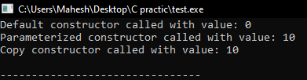

## CONCLUSION :

A constructor in C++ is to initialize an object's data members and allocate resources when the object is created. It ensures that the object is in a valid state from the moment it is instantiated. In this lab work, we have understod the different types of constructor in C++ programming. Students have get well knowledge of concept of constructor in C++ programming language.